Docker Task 02
- Create a tomcat container on 8080 and deploy sample application in tomcat.
Prerequisites
  - Docker installed
  - Port 8080 open
systemctl status docker
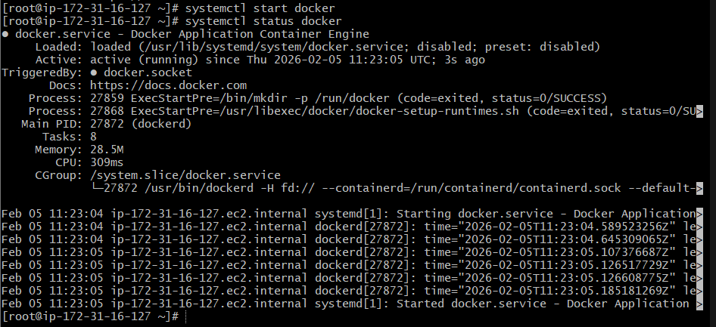
Steps
Step 1: Pull Tomcat image
docker pull tomcat:latest
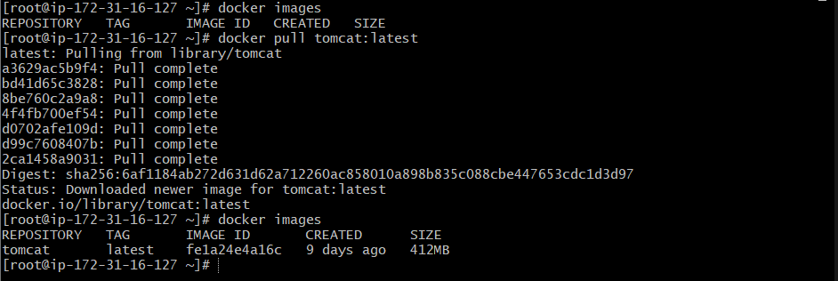

Step 2: Run Tomcat container
docker container run -itd -p 8080:8080 --name tomcat-8080 tomcat:latest
docker ps
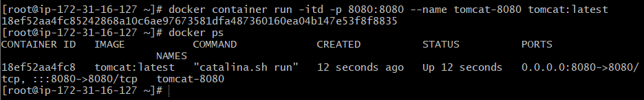

Step 3: Deploy sample application
docker exec -it tomcat-8080 /bin/bash
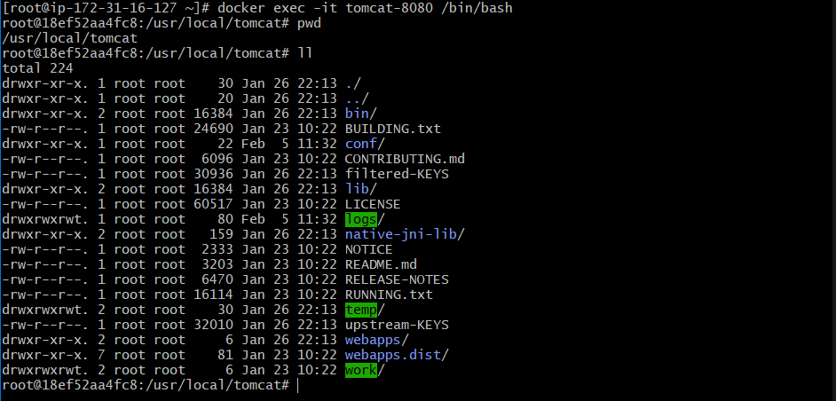

Inside container:
cd webapps
wget https://tomcat.apache.org/tomcat-9.0-doc/appdev/sample/sample.war
exit
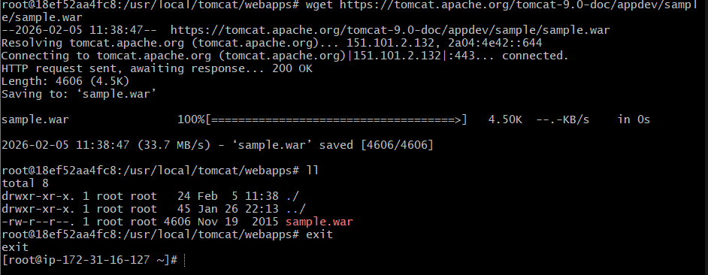

Step 4: Verify
Open browser:
http://<host-ip>:8080
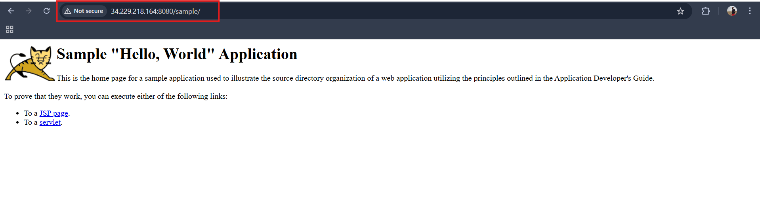

- Create volume and deploy tomcat container on port 8081.
Prerequisites
  - Docker running
  - Port 8081 available
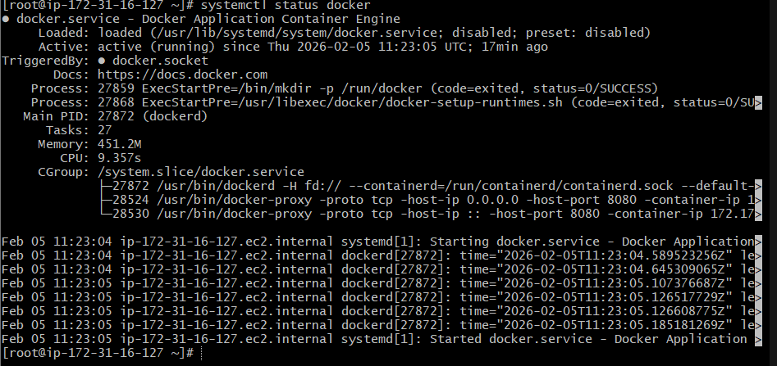
Steps
Step 1: Create volume
docker volume create tomcat-volume
docker volume list

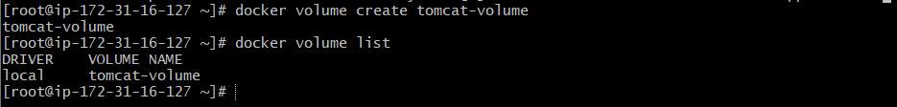
cd /var/lib/docker/volumes
cd tomcat-volume
cd _data
wget https://tomcat.apache.org/tomcat-9.0-doc/appdev/sample/sample.war
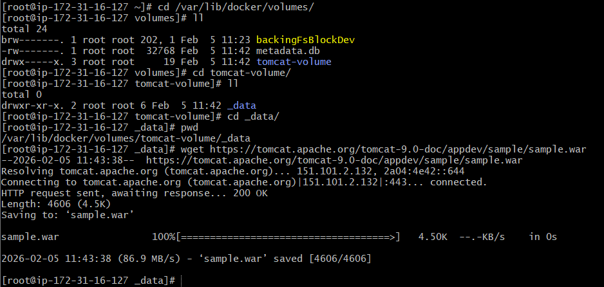

Step 2: Run Tomcat with volume
docker run -itd -p 8081:8080 -v /var/lib/docker/volumes/tomcat-volume/_data:/usr/local/tomcat/webapps tomcat:latest
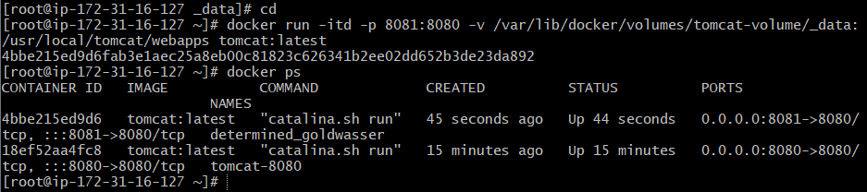
Step 3: Verify
http://<host-ip>:8081
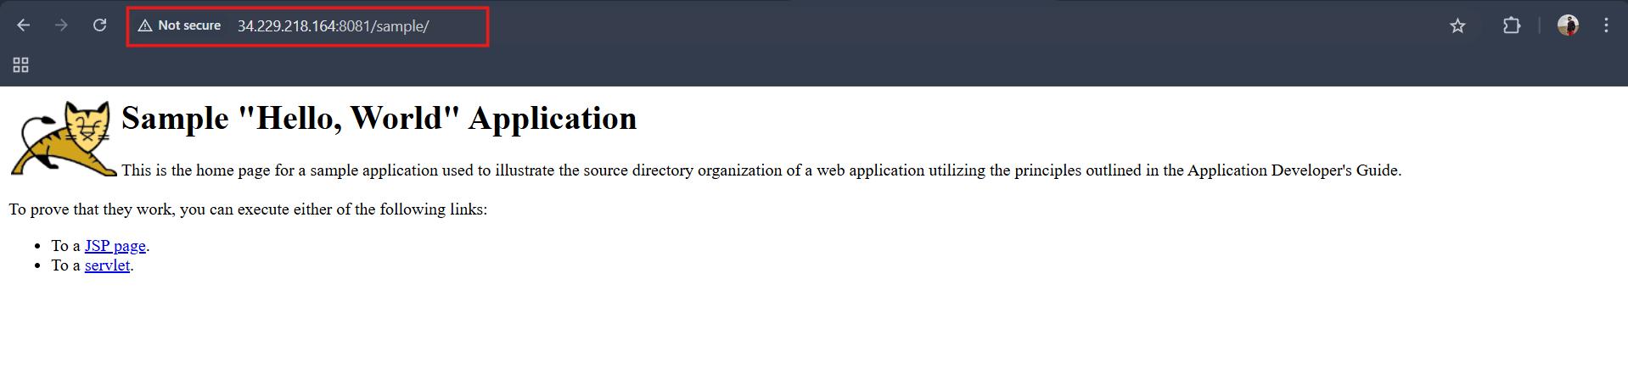

- Limit the nginx container to 500 MB.
Prerequisites
  - Docker installed
  - Port 80 or alternate port available
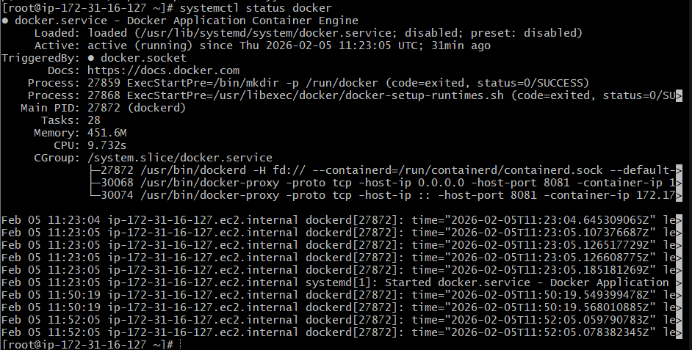
Steps
Step 1: Run Nginx with memory limit
docker run -itd --name nginx-limit --memory=500m -p 80:80 nginx
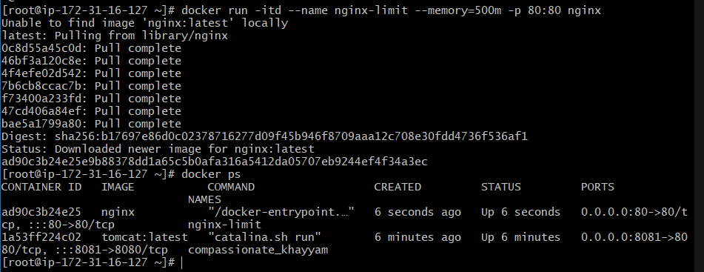
docker stats
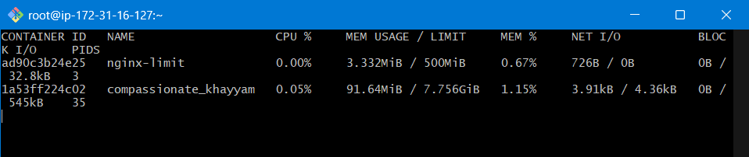
Step 2: Verify memory limit
docker inspect nginx-limit | grep -i memory

- Create a sample docker file using below instructions.
  - Base module as amazonlinux:latest
  - Maintainer you name
  - Install nginx
  - COPY one index.html file to image
  - Expose on port 80
  - Command to start the nginx container
Prerequisites
  - Basic Linux commands
  - Dockerfile and index.html created in same directory

Step 1: Create index.html
vi index.html
<!DOCTYPE html>
<html>
<head>
<title>Nginx Docker</title>
</head>
<body>
<h1>Nginx running on Amazon Linux</h1>
</body>
</html>

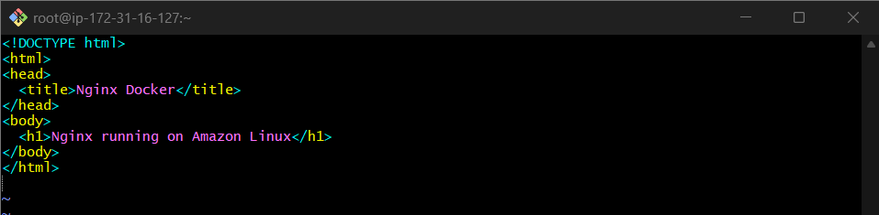
Step 2: Create Dockerfile
vi Dockerfile
#5.Base module as amazonlinux:latest
FROM amazonlinux:latest

#6.Maintainer you name
MAINTAINER shaikh shahbazz

#7.Install nginx
RUN yum update -y && \
yum install -y nginx && \
yum clean all

#8.COPY one index.html file to image
COPY index.html /usr/share/nginx/html/index.html

#9.Expose on port 80
EXPOSE 80

#10.Command to start the nginx container
CMD ["nginx", "-g", "daemon off;"]

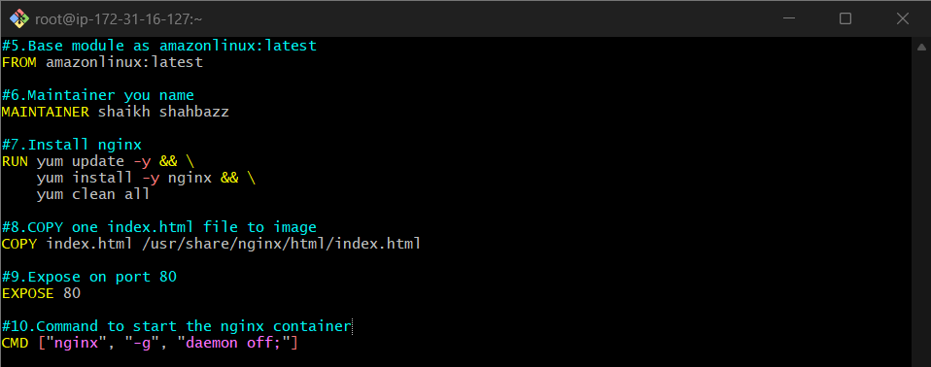
Step 3: Build Docker image
docker build -t amazon-nginx .
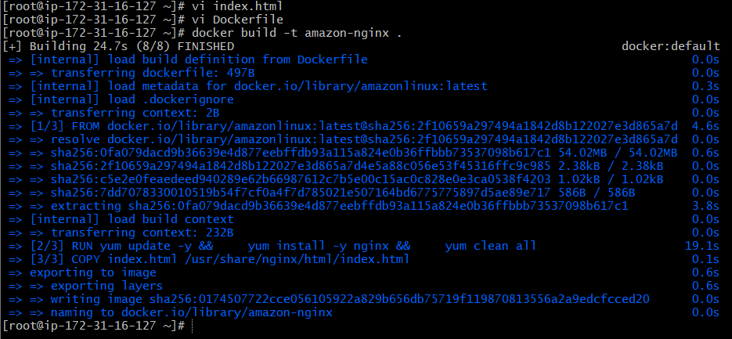
docker images
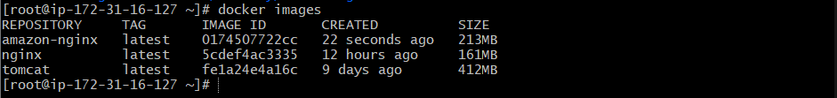
docker run -d -p 82:80 amazon-nginx
docker ps
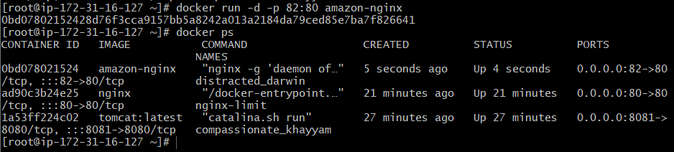
Step 3: Verify
http://<host-ip>:82
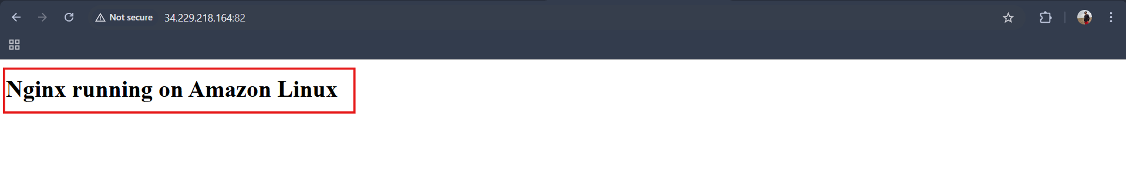

- Push image to Docker hub
Prerequisites
Docker Hub account
Docker logged in

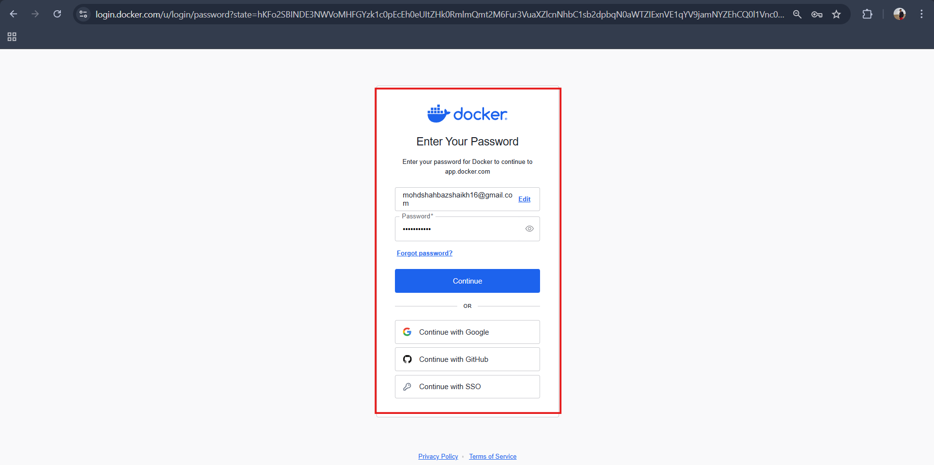

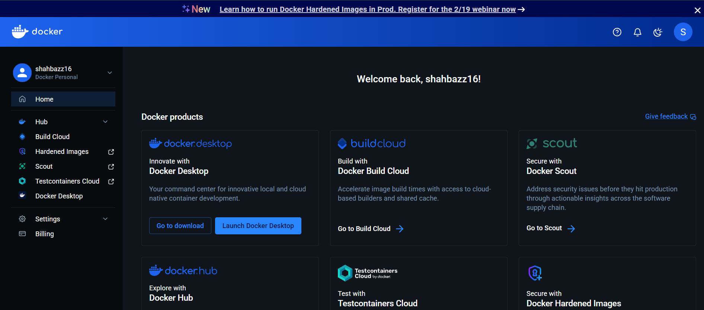

Step 1: Login
docker login
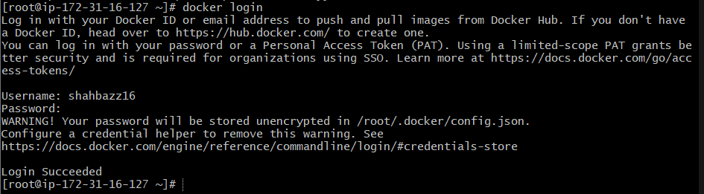
Tag the image
docker tag amazon-nginx shahbazz16/amazon-nginx:latest
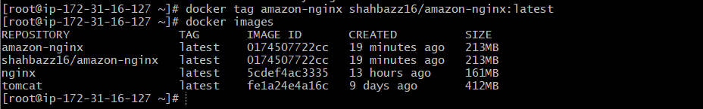

Step 2: Push image
docker push shahbazz16/amazon-nginx:latest
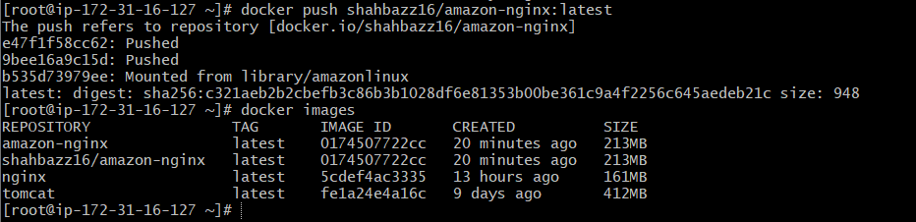

Step 3: Verify

Login to Docker Hub


Check repository exists
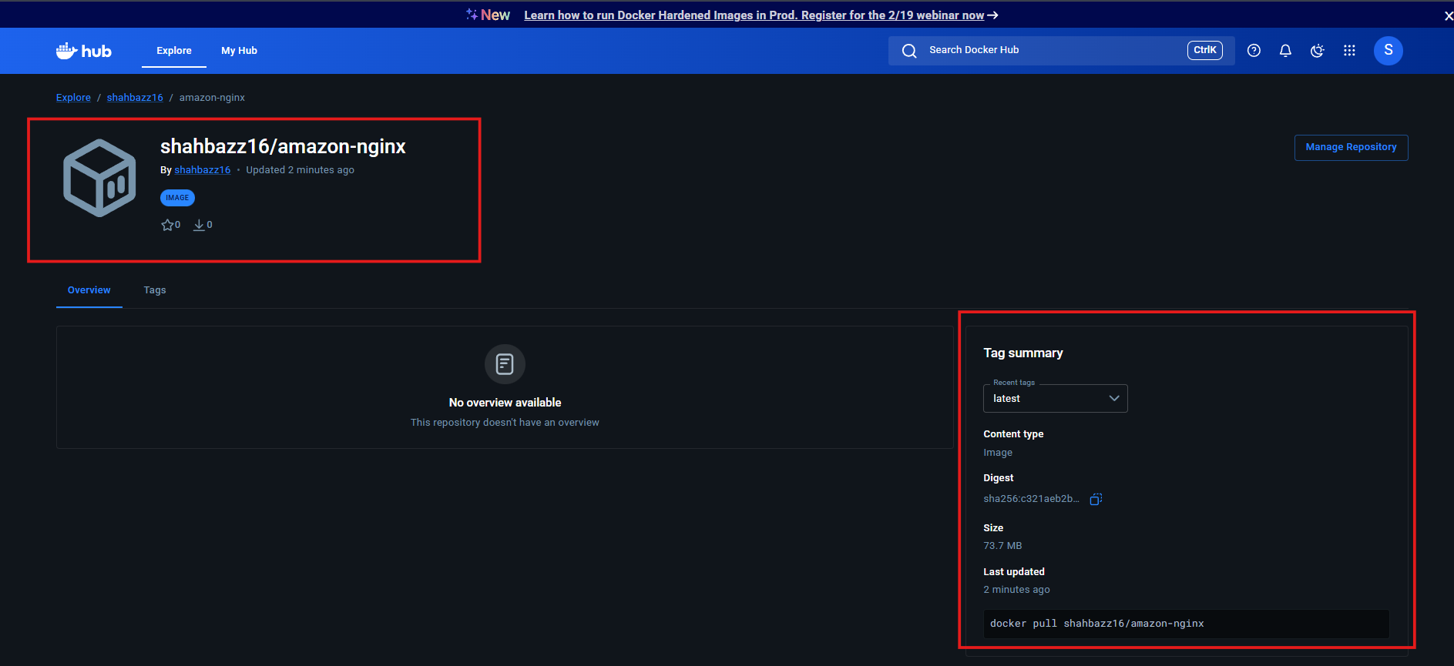

- push image to AWS ECR
Prerequisites
  - AWS account
  - AWS CLI configured
aws configure
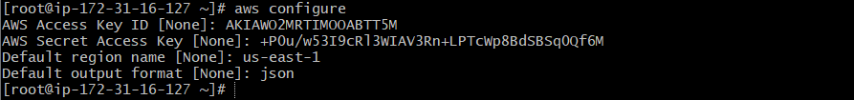
Steps
Step 1: Create ECR repository
aws ecr create-repository --repository-name amazon-nginx --region us-east-1
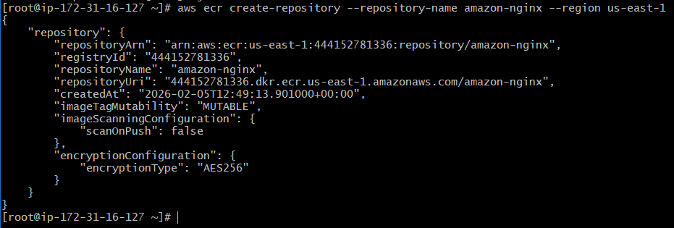

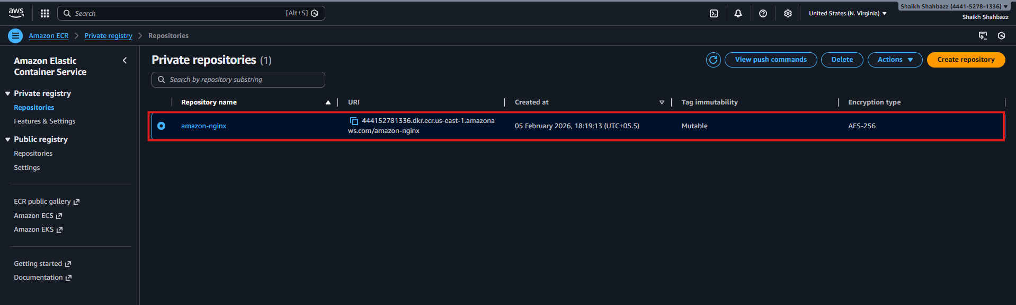

Step 2: Authenticate Docker to ECR
aws ecr get-login-password --region us-east-1 | docker login --username AWS –password-stdin 444152781336.dkr.ecr.us-east-1.amazonaws.com
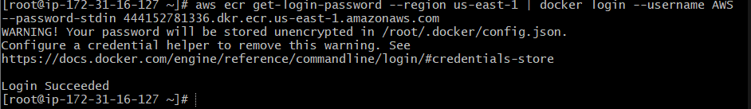
Step 3: Tag image
docker tag amazon-nginx:latest 444152781336.dkr.ecr.us-east-1.amazonaws.com/amazon-nginx:latest
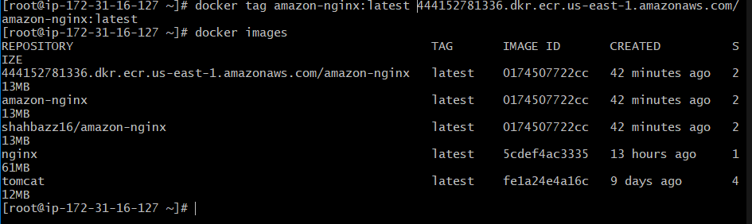
Step 4: Push image to ECR
docker push 444152781336.dkr.ecr.us-east-1.amazonaws.com/amazon-nginx:latest
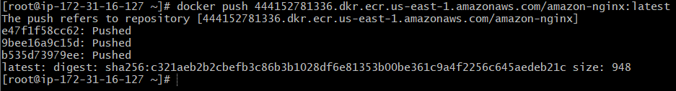

Final Verification:
Goto AWS ECR Repo <amazon-nginx> images
